Children Sabbath School Lesson #57 for 1-4-2014
Song for opening the Sabbath School:

“Trust in the Lord with all thine heart”

(A Song from Proverbs 3:5-6, 11)

Trust in the LORD with all thine heart; and lean not unto thine own understanding.
In all thy ways acknowledge him, and he shall direct thy paths.

My son, despise not the chastening of the LORD;
neither be weary of his correction:

In all thy ways acknowledge him, and he shall direct thy paths.

Opening Prayer – requesting one of the little ones or mommies or daddies to give prayer

Lesson #57:” As a Child” Part 3

John 9:4 (KJV)
I must work the works of him that sent me, while it is day: the night cometh, when no man can work.

This week boys and girls, we will end our lesson with Part 3 of our study, “As a Child”!

Colossians 3:22 (KJV)
Servants, obey in all things [your] masters according to the flesh; not with eye service, as menpleasers; but in singleness of heart, fearing God:
Colossians 3:23 (KJV)
And whatsoever ye do, do [it] heartily, as to the Lord, and not unto men;
Colossians 3:24 (KJV)
Knowing that of the Lord ye shall receive the reward of the inheritance: for ye serve the Lord Christ.
Ecclesiastes 9:10 (KJV)
Whatsoever thy hand findeth to do, do [it] with thy might; for [there is] no work, nor device, nor knowledge, nor wisdom, in the grave, whither thou goest.
Isaiah 42:1 (KJV)
Behold my servant, whom I uphold; mine elect, [in whom] my soul delighteth; I have put my spirit upon him: he shall bring forth judgment to the Gentiles.
Let’s continue in our book Desire of Ages, Chapter #7, pages 73–74

Throughout His life on earth, Jesus was an earnest and constant worker. He expected much; therefore He attempted much. After He had entered on His ministry, He said, "I must work the works of Him that sent Me, while it is day: the night cometh, when no man can work." John 9:4. Jesus did not shirk care and responsibility, as do many who profess to be His followers. It is because they seek to evade this discipline that so many are weak and inefficient. They may possess precious and amiable traits, but they are nerveless and almost useless when difficulties are to be met or obstacles surmounted. The positiveness and energy, the solidity and strength of character, manifested in Christ are to be developed in us, through the same discipline that He endured. And the grace that He received is for us. {DA 73.1}

So long as He lived among men, our Saviour shared the lot of the poor. He knew by experience their cares and hardships, and He could comfort and encourage all humble workers. Those who have a true conception of the teaching of His life will never feel that a distinction must be made between classes, that the rich are to be honored above the worthy poor.
{DA 73.2}

Question: Boys & girls, what did Jesus say after he had entered on His ministry? And, how did He handle care and responsibility different from His profess followers?

Answer: He said, "I must work the works of Him that sent Me, while it is day: the night cometh, when no man can work”. And, Jesus did not shirk from care and responsibility, as do many who profess to be His followers. It is because they seek to evade this discipline that so many are weak and inefficient.

Jesus carried into His labor cheerfulness and tact. It requires much patience and spirituality to bring Bible religion into the home life and into the workshop, to bear the strain of worldly business, and yet keep the eye single to the glory of God. This is where Christ was a helper. He was never so full of worldly care as to have no time or thought for heavenly things. Often He expressed the gladness of His heart by singing psalms and heavenly songs. Often the dwellers in Nazareth heard His voice raised in praise and thanksgiving to God. He held communion with heaven in song; and as His companions complained of weariness from labor, they were cheered by the sweet melody from His lips. His praise seemed to banish the evil angels, and, like incense, fill the place with fragrance. The minds of His hearers were carried away from their earthly exile, to the heavenly home. {DA 73.3}

Jesus was the fountain of healing mercy for the world; and through all those secluded years at Nazareth, His life flowed out in currents of sympathy and tenderness. The aged, the sorrowing, and the sin-burdened, the children at play in their innocent joy, the little creatures of the groves, the patient beasts of burden,--all were happier for His presence. He whose word of power upheld the worlds would stoop to relieve a wounded bird. There was nothing beneath His notice, nothing to which He disdained to minister. {DA 74.1}

Question: Boys & girls, what did Jesus carry into His Labor? And, what is required to bring into the home life, the workshop in order to keep the eye single to the glory of God?

Answer: He carried cheerfulness and tact. And, It requires much patience and spirituality to bring Bible religion into the home life and into the workshop, to bear the strain of worldly business, and yet keep the eye single to the glory of God.

Thus as He grew in wisdom and stature, Jesus increased in favor with God and man. He drew the sympathy of all hearts by showing Himself capable of sympathizing with all. The atmosphere of hope and courage that surrounded Him made Him a blessing in every home. And often in the synagogue on the Sabbath day He was called upon to read the lesson from the prophets, and the hearts of the hearers thrilled as a new light shone out from the familiar words of the sacred text. {DA 74.2}

Question: Boys & girls, how did Jesus draw the sympathy of all hearts? And, what was He called to do in the synagogue on the Sabbath Day?

Answer: He drew the sympathy of all hearts by showing Himself capable of sympathizing with all. And, He was called upon to read the lesson from the prophets, and the hearts of the hearers thrilled as a new light shone out from the familiar words of the sacred text.

Song: Let’s learn a beautiful hymn together dear ones!

Oh Lord, Use Me

Use me Lord (echo) to feed the hungry, (echo)
Use me Lord (echo) to help the poor, (echo)
Let me lift the dying, hurting soul to Calvary,
Let me reach out and touch them with your Word.
Use me Lord (echo) to show compassion, (echo)
Use me Lord (echo) to feel their need, (echo)
Let me be a light to show the way to the only true provision,
Let me plant the seed, Oh Lord use me.

Yet Jesus shunned display. During all the years of His stay in Nazareth, He made no exhibition of His miraculous power. He sought no high position and assumed no titles. His quiet and simple life, and even the silence of the Scriptures concerning His early years, teach an important lesson. The more quiet and simple the life of the child,--the more free from artificial excitement, and the more in harmony with nature,--the more favorable is it to physical and mental vigor and to spiritual strength. {DA 74.3}

Jesus is our example. There are many who dwell with interest upon the period of His public ministry, while they pass unnoticed the teaching of His early years. But it is in His home life that He is the pattern for all children and youth. The Saviour condescended to poverty, that He might teach how closely we in a humble lot may walk with God. He lived to please, honor, and glorify His Father in the common things of life. His work began in consecrating the lowly trade of the craftsmen who toil for their daily bread. He was doing God's service just as much when laboring at the carpenter's bench as when working miracles for the multitude. And every youth who follows Christ's example of faithfulness and obedience in His lowly home may claim those words spoken of Him by the Father through the Holy Spirit, "Behold My Servant, whom I uphold; Mine Elect, in whom My soul delighteth." Isaiah 42:1. {DA 74.4}

Question: Boys & girls, who is our example? And, where was Jesus a pattern for us all?

Answer: Jesus. And, in His home life He was a pattern for all children and youth. The Saviour condescended to poverty that He might teach how closely we in a humble lot may walk with God. He lived to please, honor, and glorify His Father in the common things of life.

Song: Let’s learn a beautiful song together dear ones!

I want to be like Jesus

I want to be like Jesus, I want to be like Jesus (2xs)
I have eyes that see you
Ears that hear from you
Feet to follow after you
I want to be just like you
I want to be just like Jesus!

Next Week: We will begin a new chapter in our lesson book entitle, “The Passover Visit”!
Closing Prayer – request one of the little ones or mommies or daddies to give prayer
Next Sabbath: Chapter 8 “The Passover Visit”, on Sabbath January 11, 2013.

Have a Blessed Sabbath dear one, and enjoy your activities. God Bless!
Children Sabbath School
Lesson #57
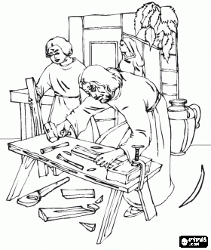
Colossians 3:23(KJV)
And whatsoever ye do, do [it] heartily, as to the Lord, and not unto men;
Word Search Puzzle

L A B O R P G G Y L H T I I O H P C W Y
J B C T B E P E K L X Y N A S A S H E T
F N H S I N A B O E S N E C N I A E A I
O S O H A R D S H I P S F G E S L E R D
P O S I T I V E N E S S F X E X M R I I
L H D E T N U O M R U S I L U B S E N L
V Z N D S P R S T D E T C E P X E D E O
F A Q E E S E W T C Z A I G P L I P S S
C S R T D X O C B R T U E A I S W F S E
D H V P C S I P N S A Y N L T T R O W L
E Y E M G T U L B O E I T I B A O U E B
N D D E T L S O E W C X N W G A M N N A
N R M T R T A C I E O C P R A E P T J I
U T O T I F N D D C T R A R L X D A R M
H A T A N E U A N I E N L O E E K I C A
S C R I I V V L O E C R D D R S V N Z K
A T S T M E J N N E S Y P U L H S X J R
W M A D E D U L C E S S D I H Y R E N I
K P W O R K S H O P S N H O N O R E D H
Y E N E R G Y J R F E S T E V G I W W S

AMIABLE
ATTEMPTED
BANISH
CAPABLE
CHEERED
CHEERFULNESS
CONCEPTION
DISTINCTION
ENDURED
ENERGY
EVADE
EXILE
EXPECTED
EXPRESSED
FOUNTAIN
FRAGRANCE
GLADNESS
HARDSHIPS
HONORED
INCENSE
INEFFICIENT
LABOR
MELODY
OBSTACLES
PATIENCE
POSITIVENESS
POSSESS
PRECIOUS
PSALMS
SECLUDED
SHIRK
SHUNNED
SOLIDITY
STRAIN
SURMOUNTED
TACT
TRAITS
WEARINESS
WORKSHOP
WORLDLY

40 of 40 words were placed into the puzzle.

Crisscross Puzzle

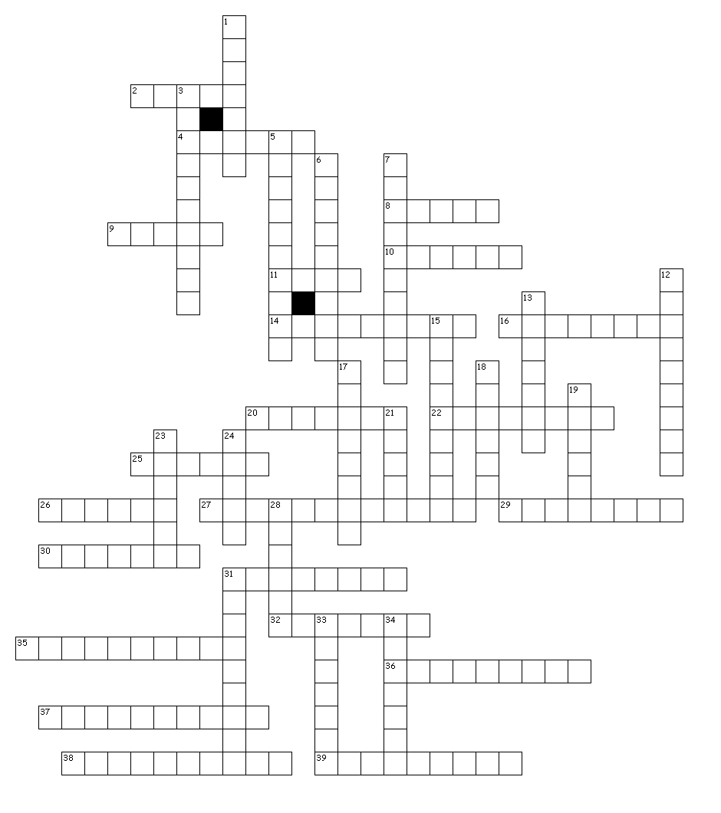

FLOWED
GROVES
BEASTS
BURDEN
DISDAINED
ATMOSPHERE
SYNAGOGUE
THRILLED
FAMILIAR
SACRED
SHUNNED
DISPLAY
EXHIBITION
MIRACULOUS
ASSUMED
TITLES
SILENCE
ARTIFICIAL
EXCITEMENT
VIGOR
UNNOTICED
POVERTY
CONSECRATING
LOWLY
TRADE
CRAFTSMEN
TOIL
CARPENTER
BENCH
MIRACLES
MULTITUDE
OBEDIENCE
SERVANT
ELECT
DELIGHTETH
PERIOD
PUBLIC
MINISTRY
PRESENCE
CAPABLE

40 of 40 words were placed into the puzzle.

Activities Answer Key

Word Search Puzzle
Solution

L A B O R + + + + + + + I + + + P C W Y
+ + + + + + + + + + + + N + + + S H E T
+ N H S I N A B + E S N E C N I A E A I
+ S O H A R D S H I P S F + + S L E R D
P O S I T I V E N E S S F + E + M R I I
+ + D E T N U O M R U S I L + + S E N L
+ + + D S P + S + D E T C E P X E D E O
+ + + E E S E + T + + A I + + + I + S S
C + + T + X O C + R T + E + + S + F S E
D H + P + S I P N S A + N L T + R O + L
E + E M G + U L B O E I T I B A + U + B
N + + E + L S O E W C X N + G A M N + A
N + + T R T A C I E O C P R + E P T + I
U T + T I F N D D C T R A R L + D A + M
H A + A + E U A N I E N L O E E + I C A
S C R + I + V L O E C R D D R S + N + K
+ T + T + E + N N E S Y P U L + S + + R
+ + A D E D U L C E S S D + + Y + E + I
+ P W O R K S H O P S N H O N O R E D H
+ E N E R G Y + + + E S + + + + + + + S

(Over, Down, Direction)

AMIABLE (20, 15, N)
ATTEMPTED (4, 15, N)
BANISH (8, 3, W)
CAPABLE (19, 15, NW)
CHEERED (18, 1, S)
CHEERFULNESS (1, 9, SE)
CONCEPTION (11, 12, NW)
DISTINCTION (18, 7, SW)
ENDURED (11, 20, NE)
ENERGY (2, 20, E)
EVADE (6, 17, NE)
EXILE (5, 8, SE)
EXPECTED (17, 7, W)
EXPRESSED (11, 11, SE)
FOUNTAIN (18, 9, S)
FRAGRANCE (18, 9, SW)
GLADNESS (5, 11, SE)
HARDSHIPS (4, 4, E)
HONORED (13, 19, E)
INCENSE (16, 3, W)
INEFFICIENT (13, 1, S)
LABOR (1, 1, E)
MELODY (17, 12, SW)
OBSTACLES (8, 12, NE)
PATIENCE (2, 19, NE)
POSITIVENESS (1, 5, E)
POSSESS (8, 10, NW)
PRECIOUS (13, 17, NW)
PSALMS (17, 1, S)
SECLUDED (11, 18, W)
SHIRK (20, 20, N)
SHUNNED (1, 16, N)
SOLIDITY (20, 8, N)
STRAIN (8, 7, SE)
SURMOUNTED (12, 6, W)
TACT (2, 14, S)
TRAITS (2, 17, NE)
WEARINESS (19, 1, S)
WORKSHOP (3, 19, E)
WORLDLY (10, 12, SE)

40 of 40 words were placed into the puzzle.

Crisscross Puzzle
Solution

Across

2. TRADE
4. TITLES
8. LOWLY
9. BENCH
10. GROVES
11. TOIL
14. OBEDIENCE
16. FAMILIAR
20. SILENCE
22. THRILLER
25. PUBLIC
26. FLOWED
27. CONSECRATING
29. PRESENCE
30. SERVANT
31. MIRACLE
32. DISPLAY
35. EXCITEMENT
36. SYNAGOGUE
37. MIRACULOUS
38. ATMOSPHERE
39. DISDAINED

Down

1. POVERTY
3. ARTIFICIAL
5. EXHIBITION
6. UNNOTICED
7. DELIGHTETH
12. CARPENTER
13. CAPABLE
15. CRAFTSMEN
17. MINISTRY
18. PERIOD
19. BEAST
21. ELECT
23. BURDEN
24. VIGOR
28. SACRED
31. MULTITUDE
33. SHUNNED
34. ASSUMED

