Children Sabbath School Lesson #56 for 12-28-2013
Song for opening the Sabbath School:

“Make a Joyful Noise unto the Lord”

(A Psalms of Praise 100:1-2)
Make a joyful noise unto the LORD, all ye lands.
Serve the LORD with gladness: come before his presence with singing.
Know ye that the LORD he [is] God:
[it is] he [that] hath made us, and not we ourselves;
[we are] his people, and the sheep of his pasture.
Enter into his gates with thanksgiving, [and] into his courts with praise: be thankful unto him, [and] bless his name.

Opening Prayer – requesting one of the little ones or mommies or daddies to give prayer

Lesson #56:” As a Child” Part 2

John 1:46 (KJV)
And Nathanael said unto him, Can there any good thing come out of Nazareth? Philip saith unto him, Come and see.

This week boys and girls, we will continue with Part 2 of our study, “As a Child”!

Luke 1:47 (KJV)
Jesus saw Nathanael coming to him, and saith of him, Behold an Israelite indeed, in whom is no guile!
Luke 1:48 (KJV)
Nathanael saith unto him, Whence knowest thou me? Jesus answered and said unto him, Before that Philip called thee, when thou wast under the fig tree, I saw thee.
Jude 1:24 (KJV)
Now unto him that is able to keep you from falling, and to present [you] faultless before the presence of his glory with exceeding joy,
Jude 1:25 (KJV)
To the only wise God our Saviour, [be] glory and majesty, dominion and power, both now and for ever. Amen.
Luke 2:52 (KJV)
And Jesus increased in wisdom and stature, and in favour with God and man.
John 1:14 (KJV)
And the Word was made flesh, and dwelt among us, (and we beheld his glory, the glory as of the only begotten of the Father,) full of grace and truth.
Let’s continue in our book Desire of Ages, Chapter #7, pages 70–72

Thus to Jesus the significance of the word and the works of God was unfolded, as He was trying to understand the reason of things. Heavenly beings were His attendants, and the culture of holy thoughts and communings was His. From the first dawning of intelligence He was constantly growing in spiritual grace and knowledge of truth. {DA 70.3}

Every child may gain knowledge as Jesus did. As we try to become acquainted with our heavenly Father through His word, angels will draw near, our minds will be strengthened, our characters will be elevated and refined. We shall become more like our Saviour. And as we behold the beautiful and grand in nature, our affections go out after God. While the spirit is awed, the soul is invigorated by coming in contact with the Infinite through His works. Communion with God through prayer develops the mental and moral faculties, and the spiritual powers strengthen as we cultivate thoughts upon spiritual things. {DA 70.4}

Question: Boys & girls, who may gain knowledge as Jesus did? And, what will draw near as we try to become acquainted with our heavenly Father through His word?

Answer: Every child. And, angels will draw near, our minds will be strengthened, our characters will be elevated and refined.

The life of Jesus was a life in harmony with God. While He was a child, He thought and spoke as a child; but no trace of sin marred the image of God within Him. Yet He was not exempt from temptation. The inhabitants of Nazareth were proverbial for their wickedness. The low estimate in which they were generally held is shown by Nathanael's question, "Can there any good thing come out of Nazareth?" John 1:46. Jesus was placed where His character would be tested. It was necessary for Him to be constantly on guard in order to preserve His purity. He was subject to all the conflicts which we have to meet, that He might be an example to us in childhood, youth, and manhood. {DA 71.1}

Satan was unwearied in his efforts to overcome the Child of Nazareth. From His earliest years Jesus was guarded by heavenly angels, yet His life was one long struggle against the powers of darkness. That there should be upon the earth one life free from the defilement of evil was an offense and a perplexity to the prince of darkness. He left no means untried to ensnare Jesus. No child of humanity will ever be called to live a holy life amid so fierce a conflict with temptation as was our Saviour. {DA 71.2}

Question: Boys & girls, how was Jesus’ life with God and where was He placed? And, how was he as a child?

Answer: A life in harmony, and Jesus was placed where His character would be tested. And, He thought and spoke as a child; but no trace of sin marred the image of God within Him. Yet He was not exempt from temptation.
The parents of Jesus were poor, and dependent upon their daily toil. He was familiar with poverty, self-denial, and privation. This experience was a safeguard to Him. In His industrious life there were no idle moments to invite temptation. No aimless hours opened the way for corrupting associations. So far as possible, He closed the door to the tempter. Neither gain nor pleasure, applause nor censure, could induce Him to consent to a wrong act. He was wise to discern evil, and strong to resist it. {DA 72.1}

Christ was the only sinless one who ever dwelt on earth; yet for nearly thirty years He lived among the wicked inhabitants of Nazareth. This fact is a rebuke to those who think themselves dependent upon place, fortune, or prosperity, in order to live a blameless life. Temptation, poverty, adversity, is the very discipline needed to develop purity and firmness. {DA 72.2}

Jesus lived in a peasant's home, and faithfully and cheerfully acted His part in bearing the burdens of the household. He had been the Commander of heaven, and angels had delighted to fulfill His word; now He was a willing servant, a loving, obedient son. He learned a trade, and with His own hands worked in the carpenter's shop with Joseph. In the simple garb of a common laborer He walked the streets of the little town, going to and returning from His humble work. He did not employ His divine power to lessen His burdens or to lighten His toil. {DA 72.3}

Question: Boys & girls, what was Jesus’ life in Nazareth familiar with? And, how was Jesus’ home life and behavior?

Answer: Poverty, self-denial, and privation. And, Jesus lived in a peasant's home, and faithfully and cheerfully acted His part in bearing the burdens of the household He was a willing servant, a loving, obedient son.

Song: Let’s learn a beautiful song together dear ones!

Now unto Him
(Jude 1:24-25)

Now unto him that is able to keep you from falling,
and to present [you] faultless before the presence of his glory with exceeding joy,
To the only wise God our Saviour, [be] glory and majesty,
dominion and power, both now and for ever. Amen.

As Jesus worked in childhood and youth, mind and body were developed. He did not use His physical powers recklessly, but in such a way as to keep them in health, that He might do the best work in every line. He was not willing to be defective, even in the handling of tools. He was perfect as a workman, as He was perfect in character. By His own example He taught that it is our duty to be industrious, that our work should be performed with exactness and thoroughness, and that such labor is honorable. The exercise that teaches the hands to be useful and trains the young to bear their share of life's burdens gives physical strength, and develops every faculty. All should find something to do that will be beneficial to themselves and helpful to others. God appointed work as a blessing, and only the diligent worker finds the true glory and joy of life. The approval of God rests with loving assurance upon children and youth who cheerfully take their part in the duties of the household, sharing the burdens of father and mother. Such children will go out from the home to be useful members of society. {DA 72.4}

Question: Boys & girls, what king of workman was Jesus? And, what physical strength, that develops every faculty?

Answer: He did not use His physical powers recklessly, but in such a way as to keep them in health, that He might do the best work in every line. He was perfect as a workman, as He was perfect in character. And, exercise that teaches the hands to be useful and trains the young to bear their share of life's burdens.

Song: Let’s learn a beautiful hymn together dear ones!

Here are my hands

Here are my hands, help them serve
Let my mouth speak your Words
And my ears to hear your voice
Got my feet to follow your path
Got my eyes to see,
All that you want me to be
And I will obey you with all my heart
And I will obey you with all my heart

Next Week: We will continue with part 3 of our study in our lesson, “As a Child”!
Closing Prayer – request one of the little ones or mommies or daddies to give prayer
Next Sabbath: Chapter 7 “As a Child” Part 3, on Sabbath January 4, 2013.

Have a Blessed Sabbath dear one, and enjoy your activities. God Bless!
Children Sabbath School
Lesson #56
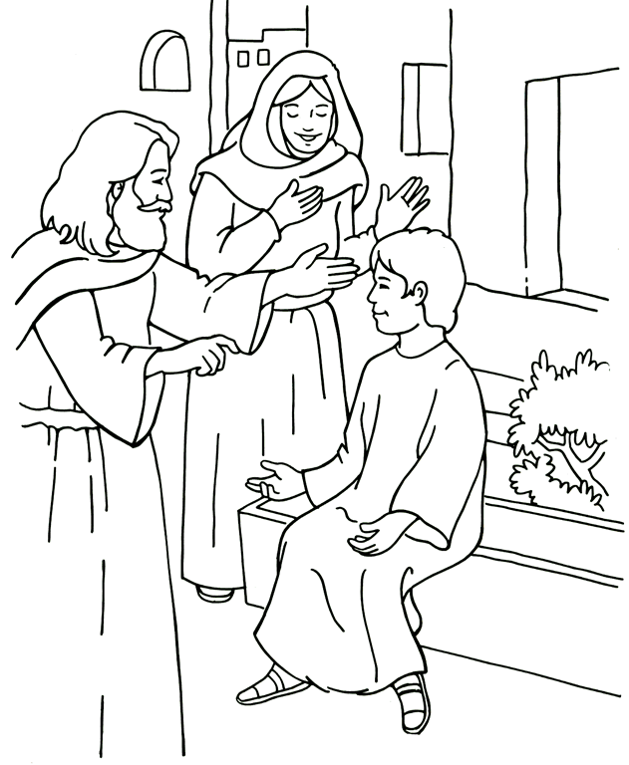
Luke 2:52 (KJV)
And Jesus increased in wisdom and stature, and in favour with God and man.
Word Search Puzzle

D S S B Y N P J P D C I Y C N J S M N T
E I Z T F T V E N S N A R E O N T M A G
D G E I N J I D E T A R O G I V N I T S
L N C X I A Y X E Q W W S G N O A H H T
O I D I A N T L E I Y E E C U F D H A R
F F L E O C L I C L I N O D M F N U N U
N I U M I I T K B T P N A S M E E P A G
U C R S G R E N L A F R Y C O N T R E G
A A K E M D A U E L H S E Z C S T O L L
H N N U N E C E I S A N G P J E A V M E
M C R E X A T C W Y S F I N Z C P E A P
E E S E F I T D L N Q D F T I M W R R D
W S M M N S A T I K U G Y E N N K B R E
X P A I L R N E R U T L U C C E W I E N
T W F A K A D O O H D L I H C T J A D I
J N R N T N E M E L I F E D G A I L D F
I O E S A C Q U A I N T E D Q K T O R E
M S N C U L T I V A T E D N A R G N N R
S O M A N H O O D E S T I M A T E J E S
C J F K D E I R T N U G U A R D C V W M

ACQUAINTED
AFFECTIONS
ATTENDANTS
AWED
CHILDHOOD
COMMUNION
CONFLICTS
CONSTANTLY
CULTIVATE
CULTURE
DARKNESS
DAWNING
DEFILEMENT
ENSNARE
ESTIMATE
EXACTNESS
EXEMPT
FACULTIES
GRAND
GUARD
HARMONY
INFINITE
INHABITANTS
INTELLIGENCE
INVIGORATED
MANHOOD
MARRED
MENTA
MORAL
NATHANAEL
OFFENSE
PERPLEXITY
PROVERBIAL
REFINED
SIGNIFICANCE
STRUGGLE
UNFOLDED
UNTRIED
UNWEARIED
WICKEDNESS

40 of 40 words were placed into the puzzle.

Cryptogram Puzzle #1
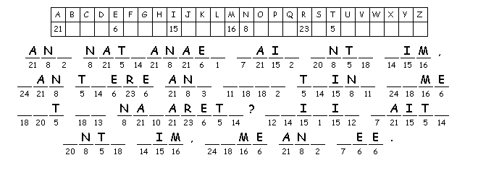
The character style to solve the cryptogram puzzle #1 phrase is by Number
A clue can be found on page #1

Cryptogram Puzzle #2
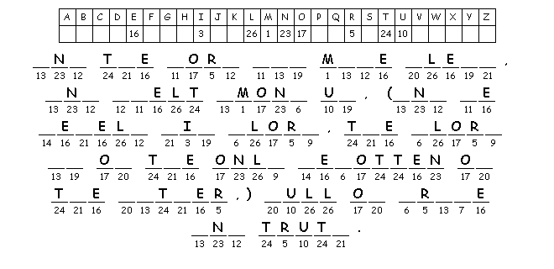
The character style to solve the cryptogram puzzle #2 phrase is by Number
A clue can be found on page #1

Crisscross Puzzle

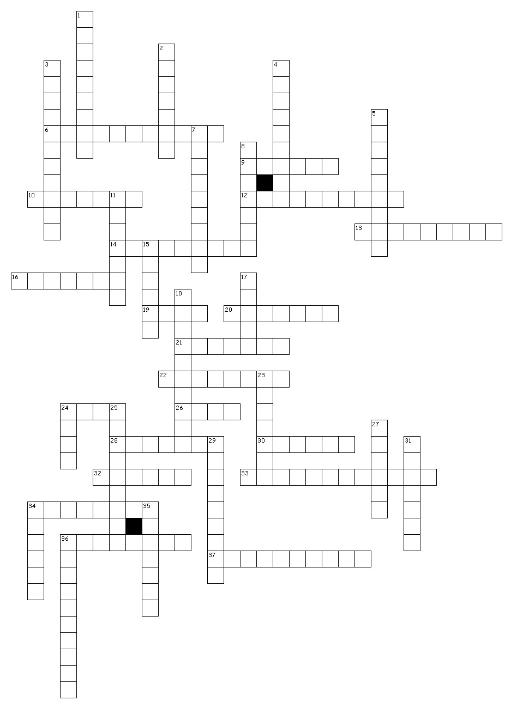

FIERCE
DEPENDENT
FACULTY
SOCIETY
SELF-DENIAL
PRIVATION
SAFEGUARD
INDUSTRIOUS
IDLE
INVITE
AIMLESS
CORRUPTING
ASSOCIATIONS
TEMPTER
GAIN
APPLAUSE
CENSURE
INDUCE
CONSENT
DISCERN
RESIST
SINLESS
REBUKE
FORTUNE
PROSPERITY
BLAMELESS
POVERTY
ADVERSITY
DISCIPLINE
FIRMNESS
PEASANT
HOUSEHOLD
COMMANDER
TRADE
CARPENTER
GARB
EMPLOY
TOIL
PHYSICAL
RECKLESSLY

40 of 40 words were placed into the puzzle.

Activities Answer Key

Word Search Puzzle
Solution

D S S + Y + + + + + + I + + N + S + N +
E I + T + T + E N S N A R E O + T + A +
D G E + N + I D E T A R O G I V N I T S
L N + X + A Y X E + W W S + N O A + H T
O I D + A N T L E I + E E C U F D + A R
F F + E O C L I C L I + O D M F N + N U
N I + M I I T K B T P N + + M E E P A G
U C R + G R E N L A F R + + O N T R E G
+ A + E + D A U E L H + E + C S T O L L
H N N + N E C E I S A N G P + E A V M E
+ C + E X A T C W Y S F I N + + + E A +
E E S E F I T D L N + + F + I + + R R D
+ S M + N S A T + + U + + E + N + B R E
+ P + I L R N E R U T L U C C + W I E N
T + F A K A D O O H D L I H C T + A D I
+ N R N T N E M E L I F E D + A I L D F
I O E S A C Q U A I N T E D + + T O + E
M S N C U L T I V A T E D N A R G N N R
S O M A N H O O D E S T I M A T E + E S
C + + + D E I R T N U G U A R D + + + M

(Over, Down, Direction)

ACQUAINTED (5, 17, E)
AFFECTIONS (11, 10, SE)
ATTENDANTS (17, 10, N)
AWED (11, 3, SE)
CHILDHOOD (15, 15, W)
COMMUNION (15, 9, N)
CONFLICTS (14, 5, SW)
CONSTANTLY (1, 20, NE)
CULTIVATE (4, 18, E)
CULTURE (14, 14, W)
DARKNESS (8, 12, SW)
DAWNING (19, 16, NW)
DEFILEMENT (14, 16, W)
ENSNARE (8, 2, E)
ESTIMATE (10, 19, E)
EXACTNESS (3, 3, SE)
EXEMPT (6, 10, SW)
FACULTIES (5, 12, NE)
GRAND (17, 18, W)
GUARD (12, 20, E)
HARMONY (1, 10, NE)
INFINITE (1, 17, NE)
INHABITANTS (13, 11, NW)
INTELLIGENCE (12, 1, SW)
INVIGORATED (18, 3, W)
MANHOOD (3, 19, E)
MARRED (19, 10, S)
MENTA (20, 20, NW)
MORAL (1, 18, NE)
NATHANAEL (19, 1, S)
OFFENSE (16, 4, S)
PERPLEXITY (14, 10, NW)
PROVERBIAL (18, 7, S)
REFINED (20, 18, N)
SIGNIFICANCE (2, 1, S)
STRUGGLE (20, 3, S)
UNFOLDED (1, 8, N)
UNTRIED (11, 20, W)
UNWEARIED (11, 13, NW)
WICKEDNESS (11, 4, SW)

40 of 40 words were placed into the puzzle.

Cryptogram Puzzle #1
Solution
John 1:46
And Nathanael said unto him, Can there any good thing come out of Nazareth?
Philip saith unto him, Come and see.
The Scramble Cryptogram word puzzle

Cryptogram Puzzle #2
Solution
John1:14
And the Word was made flesh, and dwelt among us, (and we beheld his glory, the glory as of the only begotten of the Father,) full of grace and truth.
The Scramble Cryptogram word puzzle
The clues for the can be found on page #1 of the worksheet
Crisscross Puzzle
Solution

Across

6. SELF-DENIAL
9. INDUCE
10. POVERTY
12. CORRUPTING
13. DEPENDENT
14. PRIVATION
16. FORTUNE
19. TOIL
20. FACULTY
21. CONSENT
22. APPLAUSE
24. GARB
26. IDLE
28. AIMLESS
30. EMPLOY
32. REBUKE
33. ASSOCIATIONS
34. FIRMNESS
36. PHYSICAL
37. RECKLESSLY
Down

1. HOUSEHOLD
2. PEASANT
3. INDUSTRIOUS
4. COMMANDER
5. CARPENTER
7. ADVERSITY
8. DISCERN
11. TEMPER
15. INVITE
17. TRADE
18. DISCIPLINE
23. SINLESS
24. GAIN
25. BLAMELESS
27. RESIST
29. SAFEGUARD
31. CENSURE
34. FIERCE
35. SOCIETY
36. PROSPERITY

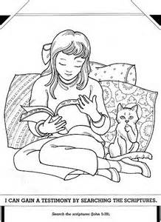
Holy Bible

Study the Holy Bible and learn of your Heavenly Father

